Haruka Kido

EE456: Digital Image Processing

Assignment 2

1. Write a MATLAB program that performs a 3x3 linear filtering operation on a given gray level image. Use linear filtering method discussed in the lecture. **Do NOT use any MATLAB built-in filtering commands.** Test your code with the following filter and “cameraman.tif” image. Submit the source code, input and filtered images.

1. Source Code (Linear Filtering: Sobel Edge Example):

1. Input and Filtered Images:

1. Use your filtering code implemented in Question 1 and perform a sharpening filtering on “lena_gray.jpg” image. Use sharpening filtering method discussed in the lecture. Give the results for two different high-boosting constant values. **Do NOT use any MATLAB built-in sharpening and filtering commands.** Submit the source code, input and filtered images.
2. Source Code (Sharpening Filter Example):

1. Input and Filtered Images (results for two different high-boosting constant values):

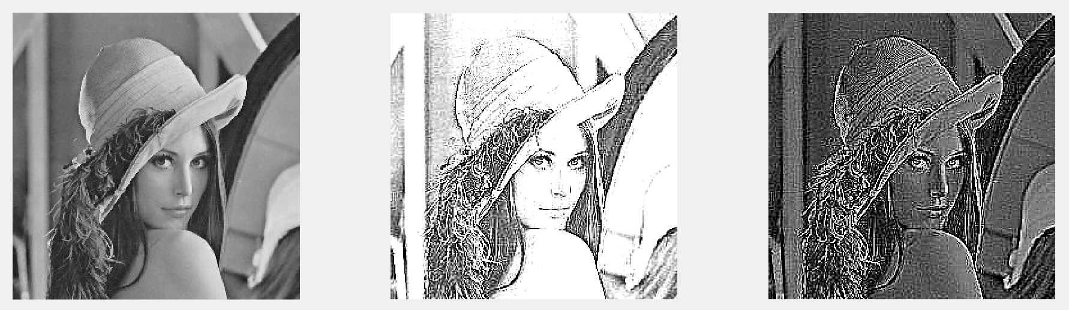

1. Apply the following filters to images using MATLAB built-in filtering commands. You can use any MATLAB built-in command. Submit the source code, input and filtered images.
2. 7x7 Average filter to “lena_gray.jpg” image:
3. Source Code:

1. Input and Filtered Images:

1. 7x7 Gaussian filter to “lena_gray.jpg” image:
   1. Source Code:

* 1. Input and Filtered Images:

1. 5x5 Median filter to “noisy_img.png” image:
   1. Source Code:

* 1. Input and Filtered Images:

1. Any Sharpening filter to “lena_gray.jpg” image:
   1. Source Code:

* 1. Input and Filtered Images:

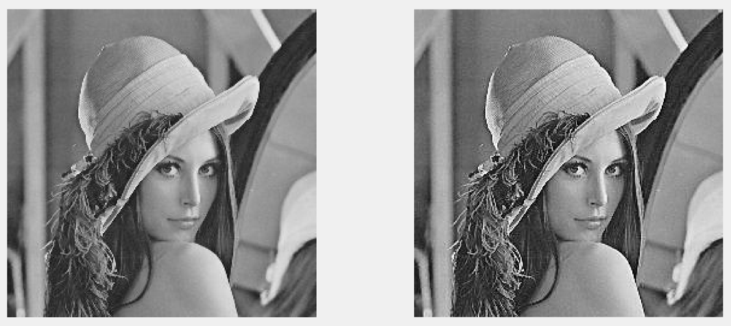

1. Sobel horizontal filter to “cameraman.tif” image:
   1. Source Code:

* 1. Input and Filtered Images:

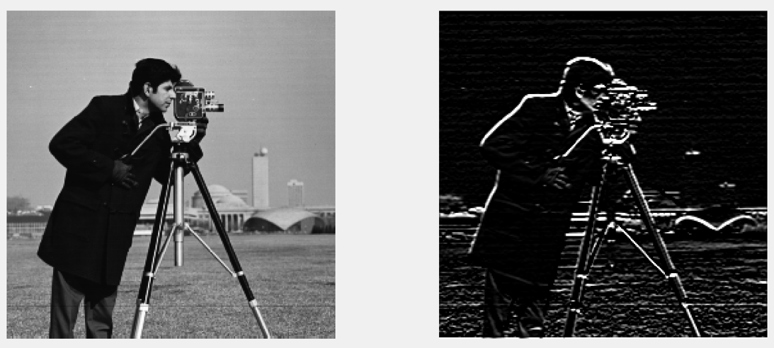

1. Sobel vertical filter to “cameraman.tif” image:
   1. Source Code:

* 1. Input and Filtered Images:

